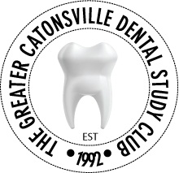
Application for Membership 2016-2017
Doctor Name: __________________________________________
Specialty: __________________________________________
Office Address: __________________________________________
__________________________________________
Office Phone: __________________________________________
Office Fax: __________________________________________
Email: __________________________________________
Webpage: __________________________________________
Suggested Topics:
__________________________________________
__________________________________________
__________________________________________

-Member dues for 2015-2016 year: $300.00
-Voluntary Contribution to Howard
Community College Hygiene Scholarship $100.00

Total Enclosed: $________
Please mail with check made payable to ‘Greater Catonsville Dental Study Club’ enclosed to:
Dr. Wink St. Cyr
2114 Edmondson Ave.
Catonsville, MD 21228
For questions, please call 410-747-6910.

